Digital Money
# Source: AI Source: Provided by: [Data Path: Persons Table -> ID Column: 1, Name_En Column: Motasem Essam] -> From: [ChatGPT] on [7/17/2026]
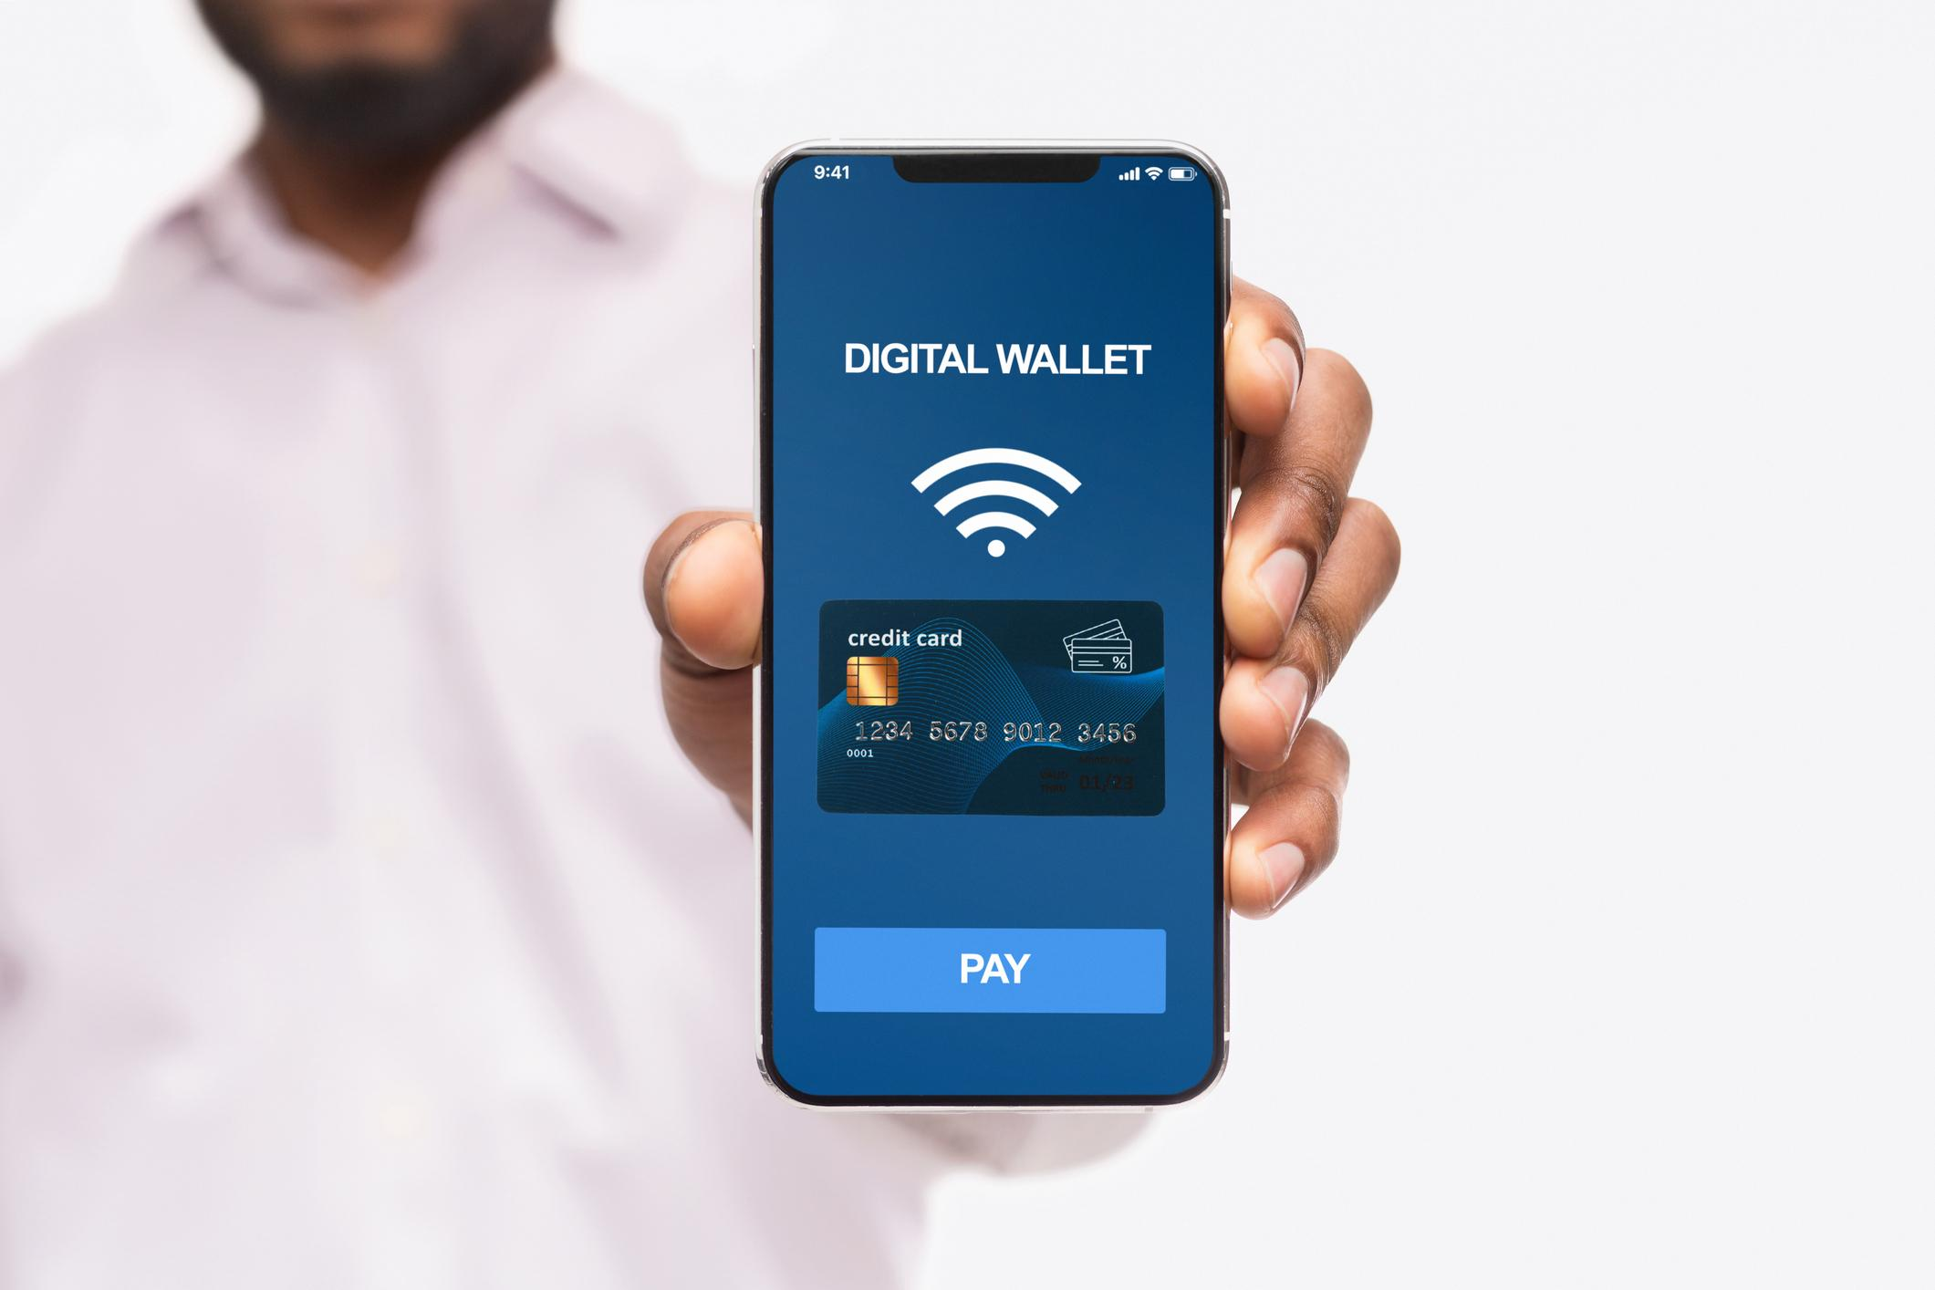
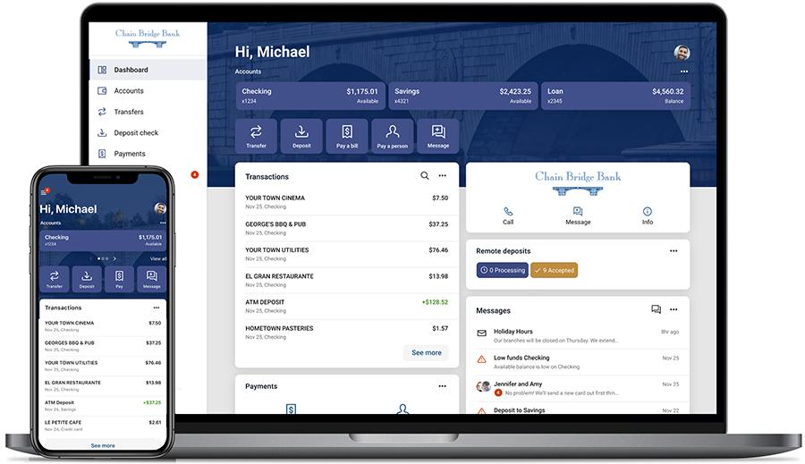
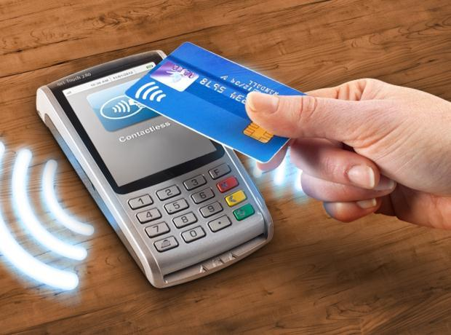
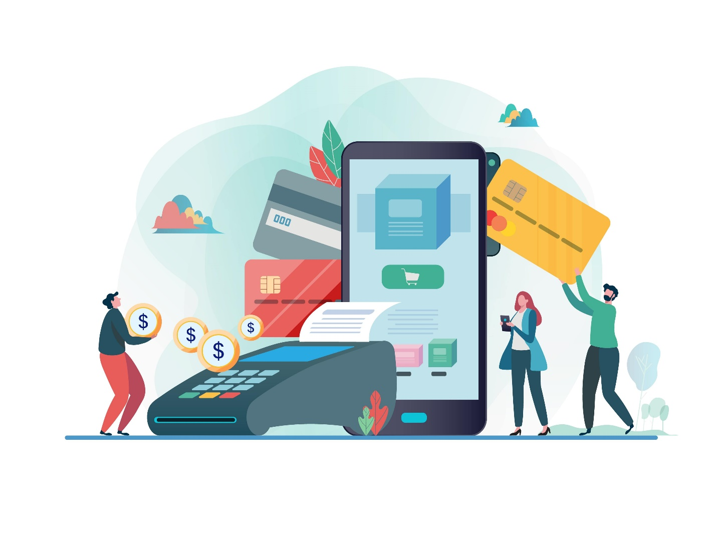
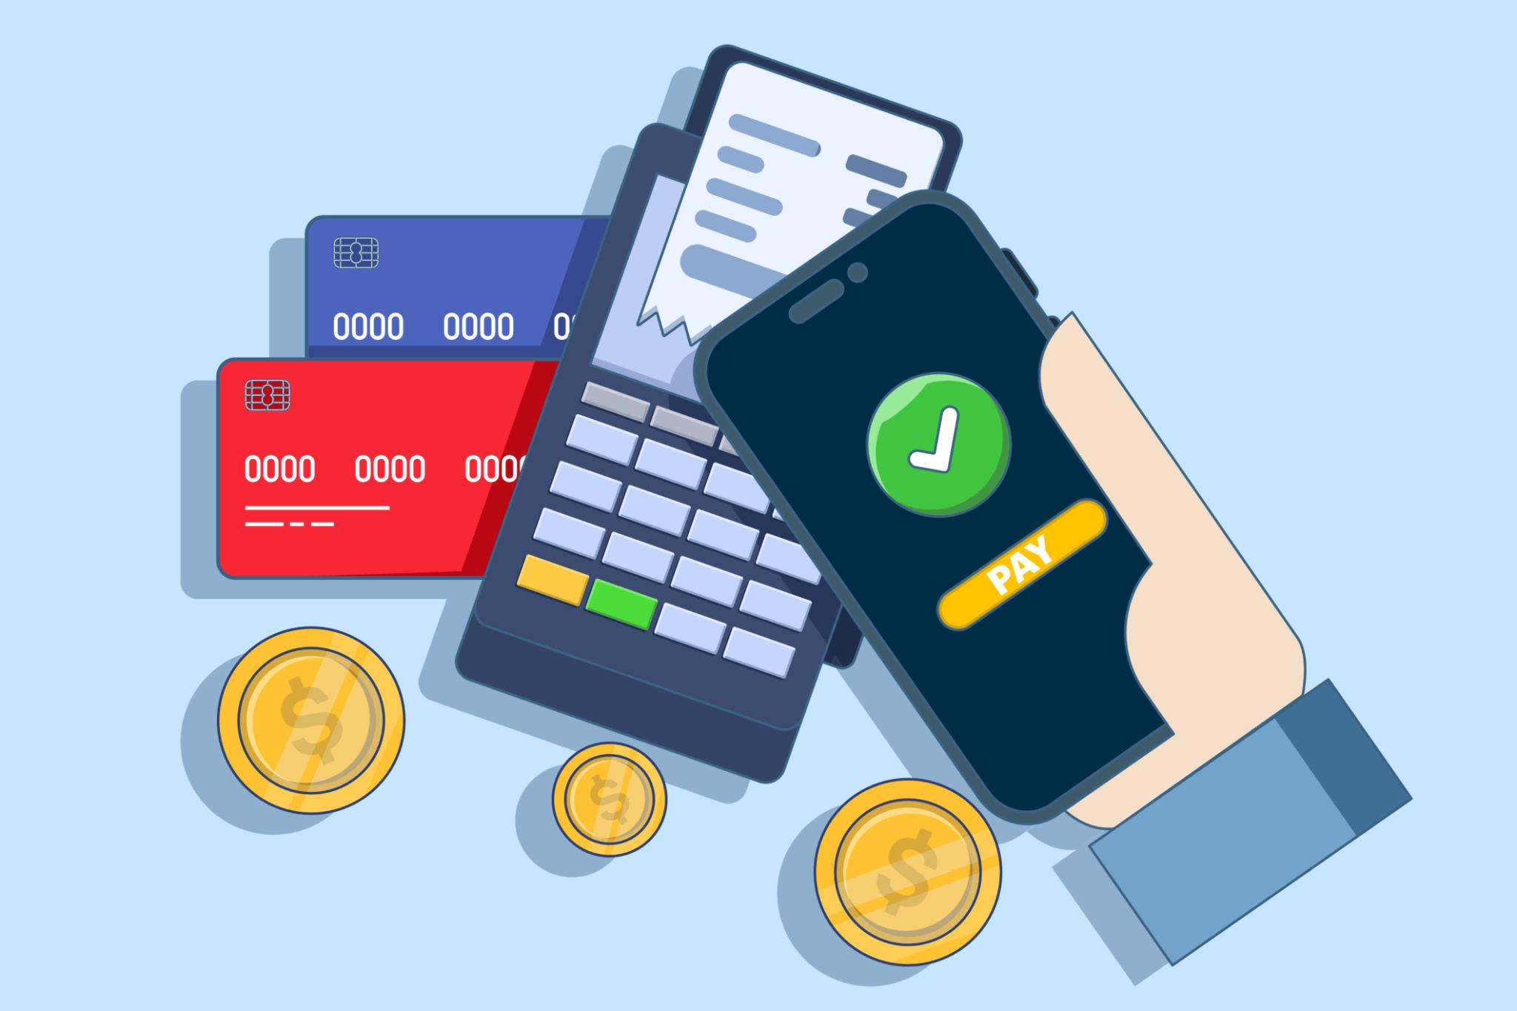
Digital Money is money that exists and is transferred in electronic form rather than as physical cash. It represents the same value as traditional currency but is stored, managed, and exchanged using computers, mobile devices, banking systems, and payment networks.
Digital money has become one of the most common forms of payment in modern economies due to its speed, convenience, and accessibility.

Definition
# Source: AI Source: Provided by: [Data Path: Persons Table -> ID Column: 1, Name_En Column: Motasem Essam] -> From: [ChatGPT] on [7/17/2026]
Digital Money is monetary value stored and transferred electronically through computers, mobile devices, banking systems, or payment networks instead of using physical coins or banknotes.

Purpose
# Source: AI Source: Provided by: [Data Path: Persons Table -> ID Column: 1, Name_En Column: Motasem Essam] -> From: [ChatGPT] on [7/17/2026]
Digital money is used to:
- Purchase goods and services.
- Transfer money between individuals.
- Pay bills.
- Receive salaries.
- Save funds electronically.
- Conduct online shopping.
- Support international transactions.

Characteristics of Digital Money
# Source: AI Source: Provided by: [Data Path: Persons Table -> ID Column: 1, Name_En Column: Motasem Essam] -> From: [ChatGPT] on [7/17/2026]
Digital money is:
- Electronic rather than physical.
- Measured in the official currency of a country (such as USD, EUR, or EGP).
- Stored in bank accounts or digital wallets.
- Transferred through secure payment networks.
- Accessible through computers and mobile devices.

How Digital Money Works
# Source: AI Source: Provided by: [Data Path: Persons Table -> ID Column: 1, Name_En Column: Motasem Essam] -> From: [ChatGPT] on [7/17/2026]
A typical digital payment follows these steps:
- Money is stored in a bank account or digital wallet.
- The user initiates a payment using a device.
- The payment network verifies the transaction.
- Funds are transferred electronically.
- The recipient receives the payment.

Types of Digital Money

1. Bank Account Money
# Source: AI Source: Provided by: [Data Path: Persons Table -> ID Column: 1, Name_En Column: Motasem Essam] -> From: [ChatGPT] on [7/17/2026]
Money stored electronically in:
- Checking accounts
- Savings accounts
- Business accounts

2. Debit Card Payments
# Source: AI Source: Provided by: [Data Path: Persons Table -> ID Column: 1, Name_En Column: Motasem Essam] -> From: [ChatGPT] on [7/17/2026]
Money is transferred directly from a bank account.
Examples:
- ATM cards
- Debit cards

3. Credit Card Payments
# Source: AI Source: Provided by: [Data Path: Persons Table -> ID Column: 1, Name_En Column: Motasem Essam] -> From: [ChatGPT] on [7/17/2026]
The financial institution pays the merchant, and the cardholder repays the borrowed amount according to the card agreement.

4. Mobile Wallets
# Source: AI Source: Provided by: [Data Path: Persons Table -> ID Column: 1, Name_En Column: Motasem Essam] -> From: [ChatGPT] on [7/17/2026]
Applications that store payment information digitally.
Examples include:
- Apple Pay
- Google Wallet
- Samsung Wallet

5. Online Payment Services
# Source: AI Source: Provided by: [Data Path: Persons Table -> ID Column: 1, Name_En Column: Motasem Essam] -> From: [ChatGPT] on [7/17/2026]
Services used to transfer money electronically.
Examples include:
- PayPal
- Stripe
- Wise

6. Bank Transfers
# Source: AI Source: Provided by: [Data Path: Persons Table -> ID Column: 1, Name_En Column: Motasem Essam] -> From: [ChatGPT] on [7/17/2026]
Electronic movement of funds between bank accounts.
Examples:
- Wire transfers
- ACH transfers
- SEPA transfers
- Instant bank transfers

Relationship to Physical Money
# Source: AI Source: Provided by: [Data Path: Persons Table -> ID Column: 1, Name_En Column: Motasem Essam] -> From: [ChatGPT] on [7/17/2026]
Digital money represents the same official currency as physical money.
Example:
- $100 in cash
- $100 in a bank account
Both represent the same monetary value, although one is physical and the other is electronic.

Applications
# Source: AI Source: Provided by: [Data Path: Persons Table -> ID Column: 1, Name_En Column: Motasem Essam] -> From: [ChatGPT] on [7/17/2026]
Digital money is used in:
- Online shopping
- Retail stores
- Utility payments
- Government services
- Salary payments
- International transfers
- Banking
- Investments

Advantages
# Source: AI Source: Provided by: [Data Path: Persons Table -> ID Column: 1, Name_En Column: Motasem Essam] -> From: [ChatGPT] on [7/17/2026]
Digital money offers:
- Fast transactions.
- Convenient payments.
- Reduced need to carry cash.
- Easy record keeping.
- Secure authentication methods.
- Global accessibility.

Limitations
# Source: AI Source: Provided by: [Data Path: Persons Table -> ID Column: 1, Name_En Column: Motasem Essam] -> From: [ChatGPT] on [7/17/2026]
Digital money:
- Requires electronic devices.
- Depends on electricity and internet access for many services.
- May be affected by technical failures.
- Requires cybersecurity protections.

Digital Money vs. Cryptocurrency
# Source: AI Source: Provided by: [Data Path: Persons Table -> ID Column: 1, Name_En Column: Motasem Essam] -> From: [ChatGPT] on [7/17/2026]
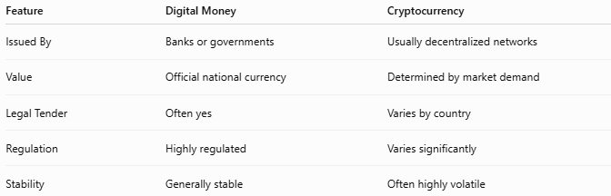
Feature | Digital Money | Cryptocurrency
Issued By | Banks or governments | Usually decentralized networks
Value | Official national currency | Determined by market demand
Legal Tender | Often yes | Varies by country
Regulation | Highly regulated | Varies significantly
Stability | Generally stable | Often highly volatile

Security Features
# Source: AI Source: Provided by: [Data Path: Persons Table -> ID Column: 1, Name_En Column: Motasem Essam] -> From: [ChatGPT] on [7/17/2026]
Digital money systems commonly use:
- Passwords
- PINs
- Encryption
- Two-factor authentication (2FA)
- Biometric authentication (fingerprint or facial recognition)
- Fraud monitoring

Common Mistakes
# Source: AI Source: Provided by: [Data Path: Persons Table -> ID Column: 1, Name_En Column: Motasem Essam] -> From: [ChatGPT] on [7/17/2026]
- Confusing digital money with cryptocurrency.
- Assuming digital money is not "real" money (it represents the same legal currency as cash).
- Believing all digital payments require the internet (some contactless systems can operate offline for limited transactions).

Interesting Facts
# Source: AI Source: Provided by: [Data Path: Persons Table -> ID Column: 1, Name_En Column: Motasem Essam] -> From: [ChatGPT] on [7/17/2026]
- In many countries, the majority of everyday financial transactions are now conducted electronically rather than with cash.
- Digital money enables instant transfers that previously required physical delivery of cash or paper checks.
- Many central banks are researching or developing Central Bank Digital Currencies (CBDCs)—digital forms of official national currency issued directly by central banks.

Comparison with Other Forms of Money
# Source: AI Source: Provided by: [Data Path: Persons Table -> ID Column: 1, Name_En Column: Motasem Essam] -> From: [ChatGPT] on [7/17/2026]
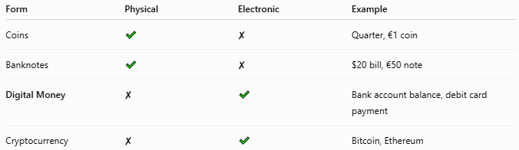
Form | Physical | Electronic | Example
Coins | ✔ | ✘ | Quarter, €1 coin
Banknotes | ✔ | ✘ | $20 bill, €50 note
Digital Money | ✘ | ✔ | Bank account balance, debit card payment
Cryptocurrency | ✘ | ✔ | Bitcoin, Ethereum

Key Points
# Source: AI Source: Provided by: [Data Path: Persons Table -> ID Column: 1, Name_En Column: Motasem Essam] -> From: [ChatGPT] on [7/17/2026]
- Digital Money exists only in electronic form.
- It represents official currencies such as USD, EUR, or EGP.
- It is stored in:
  - Bank accounts
  - Digital wallets
  - Electronic payment systems
- Digital money is widely used for:
  - Online shopping
  - Banking
  - Bill payments
  - Salary deposits
- It is different from cryptocurrency, which operates under different issuance and regulatory models.

Conclusion
# Source: AI Source: Provided by: [Data Path: Persons Table -> ID Column: 1, Name_En Column: Motasem Essam] -> From: [ChatGPT] on [7/17/2026]
Digital Money is the electronic form of officially recognized currency, enabling fast, secure, and convenient financial transactions without the need for physical cash. Stored in bank accounts and digital payment systems, it has become a fundamental part of modern commerce, banking, and everyday life. While it serves the same economic functions as coins and banknotes, digital money offers greater efficiency and accessibility through electronic technology.

